INVITATION
For the international scientific seminar
organised under the auspices of the president of Fire and Rescue Corps of Slovak republic gen. JUDr. Alexander Nejedlý, PhD. and dean of the Faculty of Wood Sciences and Technology at the Technical university in Zvolen prof. Ing. Ján Sedliačik, PhD. on the ocassion of the finish the international project no. IVF 21610132.

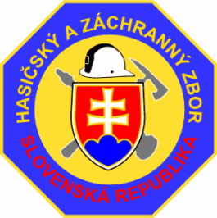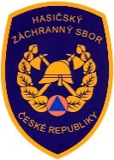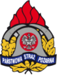

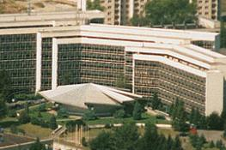
Technical University in Zvolen
T. G. Masaryk 24
960 53 Zvolen
Slovak Republic

international cooperation of the Visegrad group countries in admission of new adepts into fire and rescue corps
Project was solved with the support of the international visegrad funD

Technical University in Zvolen
Faculty of Wood Sciences and Technology
Department of Fire Protection
Masaryk 24
960 53 Zvolen
Slovak Republik

Lecture hall B 2
23rd november 2017

Program

08.00 – 08.45 Presentation

08.45 – 09,00 Closing ceremony of the international seminar
Speeches

09.00 – 10.00 Admission of candidates into Fire and Rescue Corps in nowadays in
the Visegrad Group countries and the chosen countries of the
European Union

Assoc. Prof. Dr. Peter Polakovič, PhD. Technical University in Zvolen, SR

10.00 – 10.30 Refreshment

10.30 – 11.30 Creation and standardization of the V-4 test
Assoc. Prof. Dr. Peter Polakovič, PhD. Technical University in Zvolen, SR
ml. bryg. Mgr. Piotr Wawrzynkiewicz Szkola Glowna Služby Požarniczej
Warszawa, PL

11.30 – 12.00 Statistic evaluaton and norms of the V-4 test
Mgr. Jarmila Schmidtová, PhD. Technical University in Zvolen, SR
RNDr. Vladimír Vacek Technical University in Zvolen, SR

12.00 – 13.00 Lunch break

13.15 – 14.15 Nourishment and water intake of firemen in extreme conditions in
rescue actions

Assoc. Prof. Dr. Ing. Jaroslav Jedlička, PhD. Slovak University of
Agriculture in Nitra, SR

14.15 – 15.15 Discussion to the given problematic and conclusion
of the international seminar

INFORMATION FOR PARTICIPANTS OF THE INTERNATIONAL SEMINAR

Compulsory electronic registration:

Participation of persons from your institution, please, confirm at least till 20th October 2017 via electronic mail: polakovic@tuzvo.sk and also write if you ask for accommodation a for how many people (1 night)) from 22.11.2017 to 23.11.2017

The participation on the international scientific seminar is free

Information :

Assoc. Prof. Dr. Peter Polakovič, PhD.
E mail : polakovic@tuzvo.sk
Telefón : 00421 455206475
Mobil : 00421 902298080

Organisational directions :

Travelling and accommodation expanses are paid by the organising institution.
Organisator will provide the participants of the international seminar the lunch and refreshment on the day of seminar.
Place of the object of the Technical university:

Technical University in Zvolen is 100m from the railway station and bus station in Zvolen.

T. G. Masaryk 24, 960 01 Zvolen, Slovakia
GPS geographic coordinates: 48.5719336,19.1177553

Assoc. Prof. Dr. Peter Polakovič, PhD.
Technical University in Zvolen
Faculty of Wood Sciences and Technology
Department of Fire Protection

The leading person of the international project IVF no. 21610132
Guarrantee of the internatonal seminar

