Template for Extended Abstracts for the 4th **International Scientific Conference on **Heat-Fire-Materials 2019** (HFM 2019)**

First A. Author*1, Second B. Author2 and Third C. Author3

1, 2 Authors’ Department, Institute, Organisation, Country, (e-mail: [firstauthorsname@aaaa.bbb](mailto:firstauthorsname@aaaa.bbb), secondauthorsname@aaaa.bbb)

3 Author’s Department, Institute, Organisation, Country, (e-mail: [thirdauthorsname@aaaa.bbb](mailto:thirdauthorsname@aaaa.bbb))

**\*** Corresponding author: e-mail:name@aaaa.bbbb

**Keywords:** *Keyword 1; Keyword 2; Keyword 3; Keyword 4; Keyword 5; Keyword 6* (up to 6 words arranged in alphabetical order)

**ABSTRACT**

This document presents the instructions needed to prepare the extended abstract (2-3 pages (1,000-1,500 words) in length excluding references) to be included in the proceedings of the *Heat-Fire-Materials* *2019* International Scientific Conference.

All abstracts should be written in English. In order to achieve graphical consistency, the extended abstract should be written using Microsoft Word [1]. It should start with the abstract’s title, authors, authors’ affiliation and e-mail [2] followed by the keywords (up to six) [3].

Format: The abstract should be written in MS Word. Use A4 page set-up and make all margins (top, bottom, left, right) 2.5 cm wide. Use single-spaced 12-point Times New Roman [4]. Subheadings should be bold. Justify the body of the text both left and right.

**Length of the Extended Abstract should be min. 2 and max. 3 pages (1,000-1,500 words) excluding references.**

Content: Explain the aim and scope of your study, materials and methods used, the results obtained, and main conclusions reached. Max. 2 figures/photographs can be placed in the abstract. The examples of tables and figures are introduced bellow.

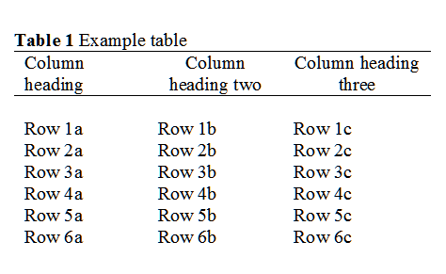

**Table 1.** Example table for the extended abstract.



**Figure 1.** Example graph for the extended abstract.

Authors are requested to send Abstracts by e-mail to [ludmila.terenova@tuzvo.sk](mailto:ludmila.terenova@tuzvo.sk). Accepted format is MS Word. Abstract written in incorrect formats will be rejected.

The submission of full papers to the *Heat-Fire-Materials* Scientific Monograph will be right after the conference.

A digital version of the *Heat-Fire-Materials 2019* Proceedings of Abstracts will be published on the conference website covering the extended abstracts which will be accepted.

**Abstract review**

The extended abstracts will be reviewed by the *Heat-Fire-Materials 2019* Scientific Committee. Abstracts which do not fulfil the format standards will be rejected.

**Acknowledgment:** The authors would like to express appreciation for the support of the sponsors [Project Number = XXXXXXX] or you can use any other expression based on the requirements of Grant Agency funding your research.

**References**:

[1] Smith, T., Jones, M.: 'The title of the paper', Hum. Fact., 2017, 1, (8), pp. 1–7

[2] Smith, T., Jones, M.: 'The title of the paper', IET Syst. Biol., 2007, 1, (2), pp. 1–7

[3] Borwn, L., Thomas, H., James, C., et al.: 'The title of the paper, IET Communications, 2012, 6, (5), pp 125-138

[4] Hodges, A., Smith, N.: 'The title of the book chapter', in Brown, S. (Ed.): 'Handbook of Systems Biology' (IEE Press, 2004, 1st edn.), pp. 1–7